1. Step 1 – Region
   * 1. Please replace the map with the new one.

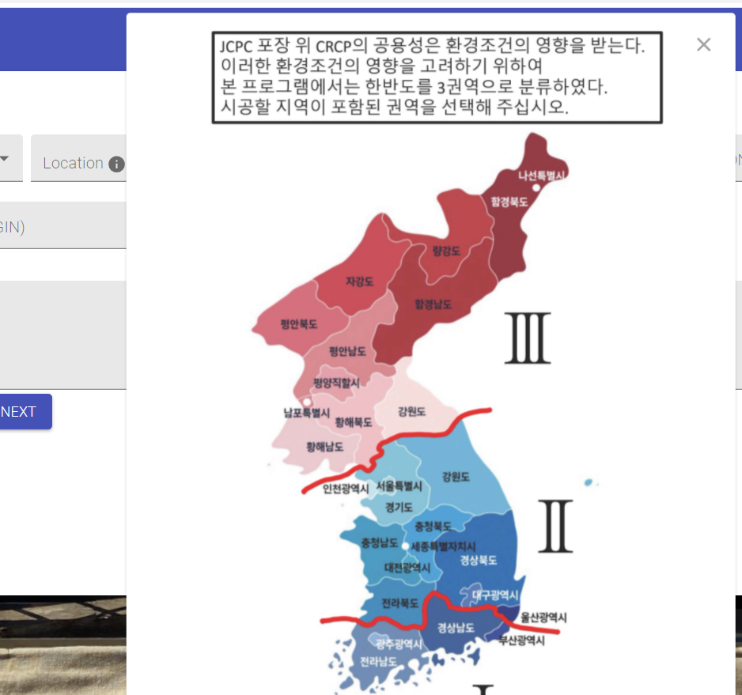

* + 1. Change 1, 2, 3 with I, II, and III. 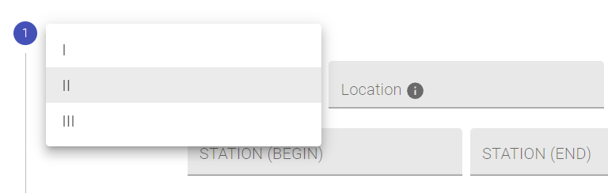

1. Step 1 - Area  
   Change “Area” to “Location”.



1. Step 1 - Area  
   * 1. Please leave the area blank so that the users could type the name of the location.
     2. Also, remove the pop-up.

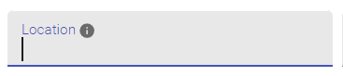

1. Step 1 - Highway  
   When clicking the Highway box, the choice box is shown. Please delete the choice box and make it a Short answer box.

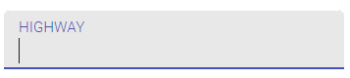

1. Step 2 & Step 3  
   Please delete all the information pop-ups in Step 2 and Step 3.

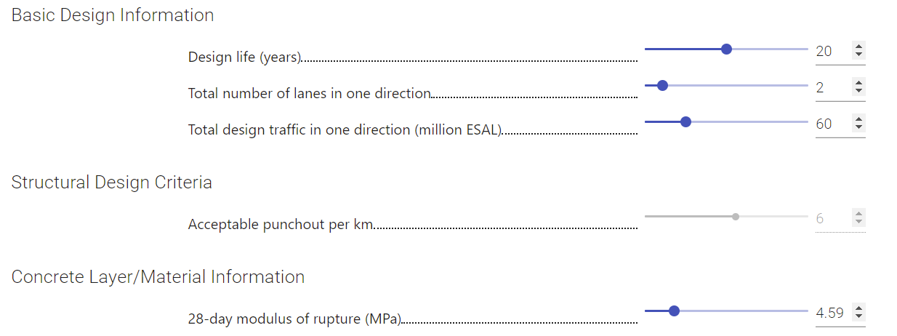

1. Step 2 - Concrete Layer/Material Information - 28-day modulus of rupture  
   Currently, the bar and number are deactivated. Please make them activated with the range from 4.5 to 5.0



1. Step 2 - Concrete Layer - Existing slab thickness  
   Also make them activated with the range from 25 to 35 cm.
2. Step 2 – Concrete Layer – Existing slab thickness  
   Change the title "Existing slab thickness (cm)" to "Existing slab thickness before milling (cm)"



1. Step 3 – Base layer thickness  
   Change the range to 10 cm to 20 cm. If feasible, provide a button in the bar. (If not, it’s ok.)
2. Step 3 - Base layer information - Modulus of base layer (MPa)  
   Make the range to 15,000 - 30,000. If feasible, provide a button in the bar. (If not, it’s ok.)
3. Step 3 – Base layer information – Composite k value (MPa/m). Change “V” in value to small v. Also, remove up/down button.  
   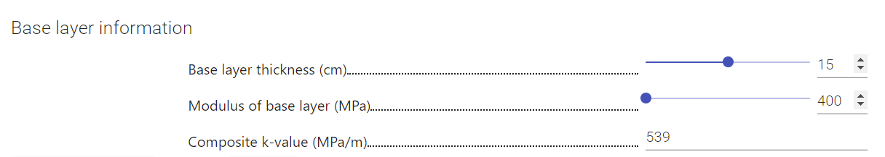
4. Result page - B  
   Change the title "Existing Slab Thickness (cm)" to "Existing Slab Thickness before Milling (cm)"
5. Result page – D  
   In the Composite K, Change the unit “psi/in” to “MPa/m”
6. Result page – E  
   In the 28-Day Modulus of Rupture, change the unit “psi” to “MPa”  
   Delete “Elastic Modulus (million psi).” In other words, the whole row
7. Result page – F  
   Change the name “Design Slab Thickness & Performance” to “Overlay Slab Thickness & Performance”
8. Result page – G  
   Change the name “CRCP” to “CRCP Overlay” and “JCPC” to “JCPC after Milling”
9. Result page – G  
   Replace “ with cm.

